DATE: May 4, 2009

TO: Post-Fire Task Force, All Members
FROM: Gary Franz, Deputy Chief
RE: Overview of Recent Fires

As requested, it is my privilege to share with you some of the key facts and lessons learned from the recent multiple-house fire event that occurred on March 14, 2009. This presentation is intended as an informative overview and should not be viewed as a comprehensive examination of this event. It is appropriate to begin this report with information about fire behavior so that as the facts of this fire are presented, they are easier to link together.

- FIRE BEHAVIOR:

- The “behavior” of fire is well studied, so much so that fire is fully predictable. Fire will occur anytime there is fuel, heat, and oxygen brought together in right proportion. Fire will then grow a spread in predictable patterns consistent with those proportions.

- The closer the proximity of burning ordinary combustible materials (fuel), the more rapidly an unchecked fire will grow and spread among those materials.

  - Heated gases, smoke, and flame will rise in air due to expansion of air molecules. This is the heat transfer principle known as “convection.”
    - Think of cooking in a pan on the stove for example, all of the heated vapors (and sometimes smoke) from your cooking rise up in a column toward the fan-hood.

  - Heat will travel from its source in all directions through invisible short and long waves of energy. This is the heat transfer principle known as “radiation.”
    - Think of Hawaii… on the beach in the sun… your body soaking up those invisible heat rays as you lay on the beach

  - Heat will travel away from its source, in and through solid objects. This is the heat transfer principle known as “conduction.”
    - If you hold on to that metal hotdog poker while it is in the campfire too long, the handle will get hot enough to burn you.

- LESSONS LEARNED:

- The particular road network in the area illustrates that where “connectivity” of streets between neighborhoods does not exist, the arrival of response forces will be delayed due to extended travel times.

- Fires of this magnitude generate temperatures of well over 1,000 degrees. Heat of this magnitude generates strong (convective) wind forces. These forces were experienced at this fire event.
- It is fact that some portions of the first structure were only seven-feet from the wall of the second structure. This fire illustrates that in those developments where fully combustible houses are only six-feet apart, especially where fences and other combustible materials are stored in this space, fire will grow and spread rapidly.

- EVENT DESCRIPTION:

The conditions at the time of this fire include darkness, air temperature at 43-45 degrees, a full cloud cover with humid air and intermittent showers, light wind with occasional gusts over 10mph, still a “normal” sleep time for residents, and minimal traffic conditions.

At 6:48am on March 14, 2009, Graham Fire & Rescue was dispatched to a “possible house fire” located in the 20500 block of 85th Ave. Ct. E., Graham. Our initial situation report from Dispatch was that “the fire was spreading to the fence and porch.” A few minutes later Dispatch updated responding crews that 9-1-1 calls were now reporting a second house on fire.

7 minutes and 33 seconds later, Engine 95 and Medic 95 arrived at this incident simultaneously. The Engine Officer then reported “a two-story residential structure fully involved in fire, with fire exposure to the house on side-D.” Side-D in this case means the neighbors house on the immediate south side of the first fire building. This exposure structure is later named as Exposure D-1. These first units combine forces to initiate defensive deck-gun and high volume fire hose operations from the street. The Engine Officer also requests a “2nd Alarm Response.”

At 8 minutes, 58 seconds after the initial dispatch, Engine 94 and Medic 94 both arrive at scene and report the attic of Exposure D-1 well involved in fire. These two units combine forces and initiate defensive deck-gun and high volume fire hose operations from the street. At 9 minutes, 40 seconds after initial dispatch, Engine 91 arrives at scene and reports two houses fully involved in fire. Engine 91 initiates a defensive deck-gun operation on the “B-Side” (north) of the first house on fire.

The Battalion Officer in charge of this shift arrives at scene at 9 minutes, 53 seconds after the initial dispatch, and assumes command. This officer performs a walk-around of the perimeter to evaluate fire spread and rescue needs. He later reports fire exposure to the houses located on the C-Side (directly behind) the primary fire building. This officer then assigns Engines 93 and 64 from the scene to re-position onto 86th Avenue for evacuation and protection of the Side-C exposure structures.

Because there is no road network to provide “connection” between these two neighborhood streets, the Engines needed to map out a “response route.” With mapping time and travel times combined, it took these Engines nearly 5 minutes of time to re-position just one-block away.

There were a total of six Engines, three Medic Units, one Ladder, one Water Tender, and four Chief Officers totaling 31 firefighters and officers operating at this incident. An additional two Engines, one Medic Unit, and one Chief Officer were “moved up” into Graham fire stations during this fire event. The fire was called “under control” approximately 1hour and 17 minutes after the initial dispatch.

- INVESTIGATION FINDINGS:

- Cause of Fire: Owner started a warming fire using dry, seasoned fire wood in an uncovered metal trash. The can was situated on a concrete pad and located outside, under the porch overhang at the SE corner of the house.

- The porch and deck at both the rear and south sides of this house was constructed of ordinary combustible wooden materials and attached to the house itself. The owner constructed the deck and porch without approved permit.

- Sometime after the fire was burning, the owner went inside and did not attend the fire for a “reported” short period of time. The owner told us the next thing he knew, his across-the-street neighbor was knocking on his door to tell him his house was on fire.

- This fire was ruled “accidental.” The likely source of ignition was sparks or embers traveling from the warming fire to nearby combustible materials stored close to the fire, and/or sparks or embers coming in contact with the porch and deck materials.

- As the fire progressed into a “free burning” state, the convective transfer of heated gases and smoke, along with the transfer of radiant heat energy caused the wooden fence between the structures, and the exterior structural materials of the house to the south to ignite and burn. Fire rapidly entered the bird blocking and eave spaces of house #2, igniting combustible materials inside the attic of the second house.

- Fire spread unchecked in the attic space of house #2 as crews were preparing for fire attack. The attic fire caused rapid failure of the entire roof structure. A major portion of the roof collapsed into the upper floor of this house and led to an explosive fire spread through the upper floor of house #2.

- The large body of these two fires combining required a substantial air supply. As more and more air is needed to supply the fire, wind drafts are generated. This “wind” drafting in and around the structures contributed to both fire growth and spread.

- The radiant heat energy emitted from the first house fire caused major damage to a house located directly behind and to the east of the initial fire building. Two other houses on either side of this rear “exposure” also received heat damage, primarily to the exterior vinyl siding materials.

- The dollar loss total as a result of these fires is estimated at $800,000. The personal and sentimental losses of the occupants cannot be calculated.

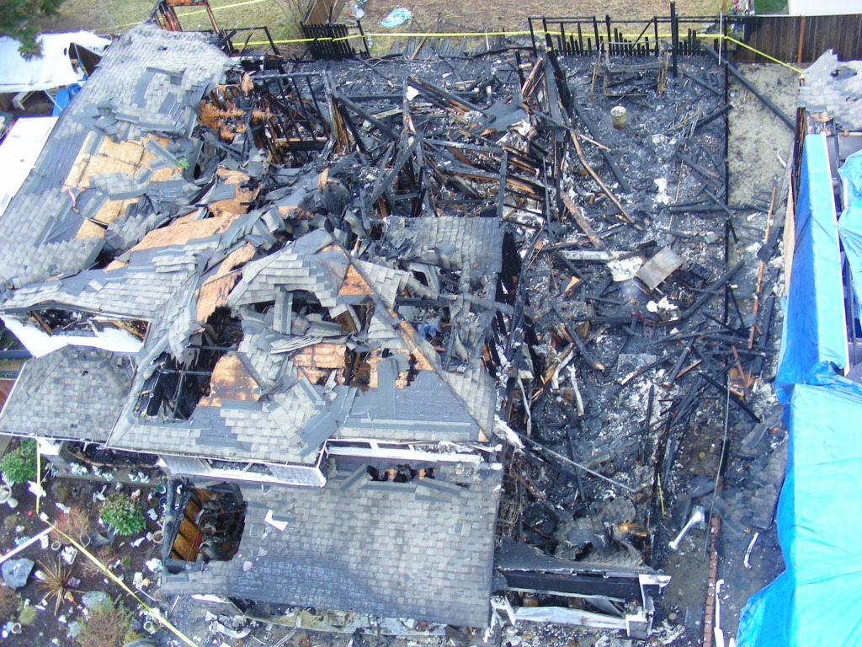
2
7 feet Space
1
3
10 feet
4

This is what remains of the house that first caught fire. At the bottom of the picture is the “front” of the house facing 85th Ave. Ct. The backyard is at the top of the picture. Notice the right side of the picture; you will see four red arrows. They point to what is left of the vertical support posts for the porch overhang, (#1, #2 and #3 show posts fallen over toward the south; #4 post is still standing). The deck and porch extend along the south side of this house toward the backyard.

Looking at the side yard setback space between houses, (see lg. green arrow upper right) you can see that the space between the first house and the neighbor’s house is reduced to approximately seven feet, for an approximate span of 20 feet. The remaining side yard space from about the #1 in the red arrow, going out then to the front of the house, is ten feet between the two houses.

Looking at the overall picture it is easy to see that the fire damage is greatest at the southeast corner (the trash can is visible in the picture to the left of #4 arrow) and shows progressively less fire damage moving west and north in the house. This helps to affirm point of fire origin.

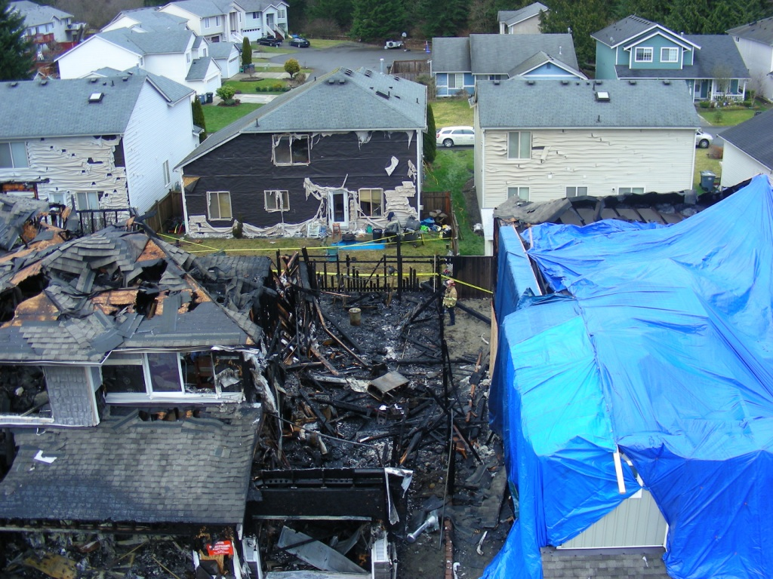
This is an overhead photo. Notice the heat and fire damage to the houses directly behind the main fire building. This photo clearly illustrates what happens to vinyl siding when exposed to a radiant heat insult. The vinyl siding exposed to this fire experienced warping, attachment-failure and collapse, melting, and burning. Vinyl siding is most prominently a poly-vinyl chloride, (PVC) product. PVC products release very toxic poisonous vapors into the air and can produce significant short and long term health consequences when inhaled.

What is also visible if one looks closely is a common “V” burn pattern across all three of the houses to the rear or east. The yellow arrows outline the “V” pattern and demonstrate that the heart of the radiant heat insult was directly east from the first house fire, which served as the primary source of heat that damaged all three rear exposure buildings.

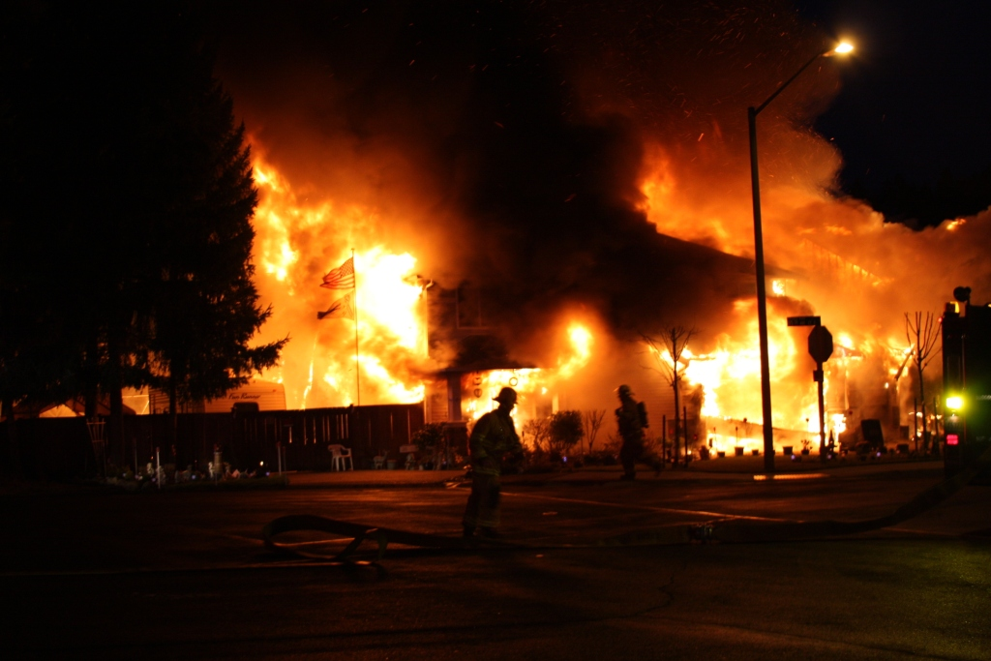
Eng. 94
Front of House #1

This photo, taken by a neighbor, shows the magnitude of fire in its early stages of growth and was taken at approximately 8 minutes after the fire department received its first report of a possible house fire.

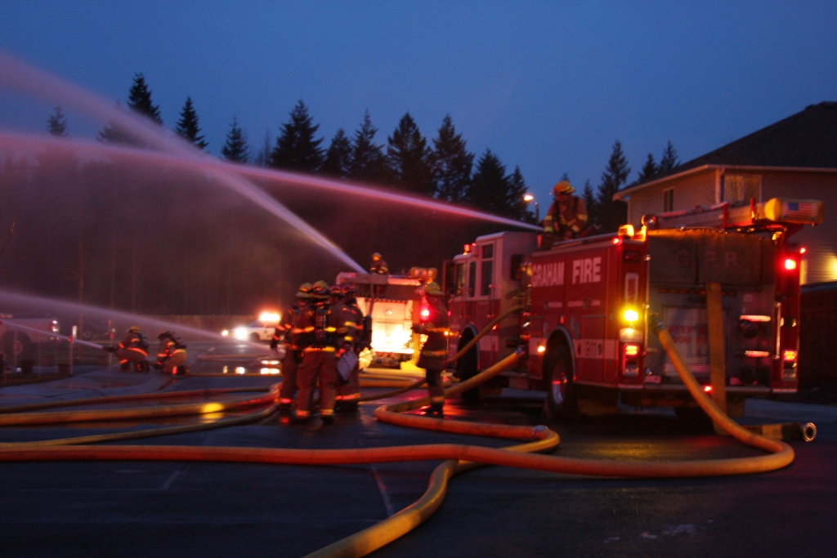
Eng. 94

This photo shows the delivery of heavy water streams from both deck-guns (top side of Engines) and high volume hose lines, (ground level streams held by firefighters).
- SUMMARY:

It was mentioned at the Task Force meeting that this fire “is” the fire predicted some time ago. In truth; this is not that fire. This fire represents for all of us an accurate “picture” of the fire still to come in a PDD development. The following reasoning supports this prediction:

- Because of the non-permitted deck and porch overhang added by the homeowner, he created a virtual PDD setback spacing, albeit 7 feet, between his house and the house next door. We can point to many, many existing PDD developments across Pierce County where the maximum spacing between side yards is only 6 feet.

- Houses from 20 feet to over 40 feet away from the main body of fire, with no direct flame contact, were significantly fire damaged. This one fact demonstrates that 10 total feet of separation between buildings is an absolute minimum space needed to reduce fire spread in neighborhoods.

- There was a permitted fence between the two fire houses. Existing PDD developments all allow fencing as well, not to mention trash, recycle bins, and other “stuff.” Fences and “stuff’ serve as ladder fuels and impede fire department access to rear yard areas.

- This neighborhood was not required to use fire resistive building materials. Neither has this been a requirement in any of the existing PDD developments.

- This neighborhood was not required to incorporate fire-rated construction methods. Neither have any of the existing PDD developments across the County.

It is our continued concern for these types of fire risks that led us to approach the County Council and request a re-activation of the Task Force. Our effort in part, is to convince Task Force members to advise the Council to require the full compliance of fire and life safety measures contained in the current PDD regulations, retro-actively, over any and all PDD development applications that have not otherwise completed their application process.

The current PDD regulations were established as a result of the County Council acknowledging an unacceptable level of risk from fires in developments with limited spacing. The Council adopted an Emergency Resolution that placed a moratorium on all pending PDD applications as a result. An advisory Task Force was assembled, which later advised the Council to initiate specific fire and life safety measures to reduce the acknowledged risks. The Council adopted every recommendation of the Task Force. The existing PDD regulations are a reasoned and responsible set of solutions that help to protect the public’s safety. Vesting rights do not extend to matters of public safety. Vesting of a project should not be permitted to trump the public’s right to safety.

Gary G. Franz, Deputy Fire Chief
Graham Fire & Rescue

